**Technical Users Guide**

**User Manual**

**VERSION 1.0.0**

**Index**

|  |  |
| --- | --- |
| About | Page No. |
| * Tools and Technologies used in ZAB | **3** |
| * User Account Privileges | **6** |
| * Software Installation with Administrator right | **7** |
| * Enable Remote Desktop | **7** |
| * Configuration of Apache Tomcat | **7** |
| * JAVA Configuration | **8** |
| * Configuration of POS Device | **8** |
| * Configure ZAB.SYS file | **9** |
| * Setup simultaneous Remote login for multiple users | **10** |
| * SQL Server Installation Prerequisite and Installation Guide | **13** |
| * SQL Server Backup and Restore | **31** |

* **Tools and Technologies used in ZAB**
* **JAVA**
* **ZAB Framework**
* **Apache Tomcat**
* **Microsoft SQL Server**
* **Crystal Report**
* **How to Deploy ZAB on local server**

Prerequisite of deploying ZAB software on your device

**>> (JAVA,SQL server, Apache tomcat) installed on your device**

**>> restore your business database (zabdb) on sql server.**

**Now follow the steps……………………..**

**Step 1 : Open your tomcat installation folder and put zab folder on webapps folde ( picture bellow )**

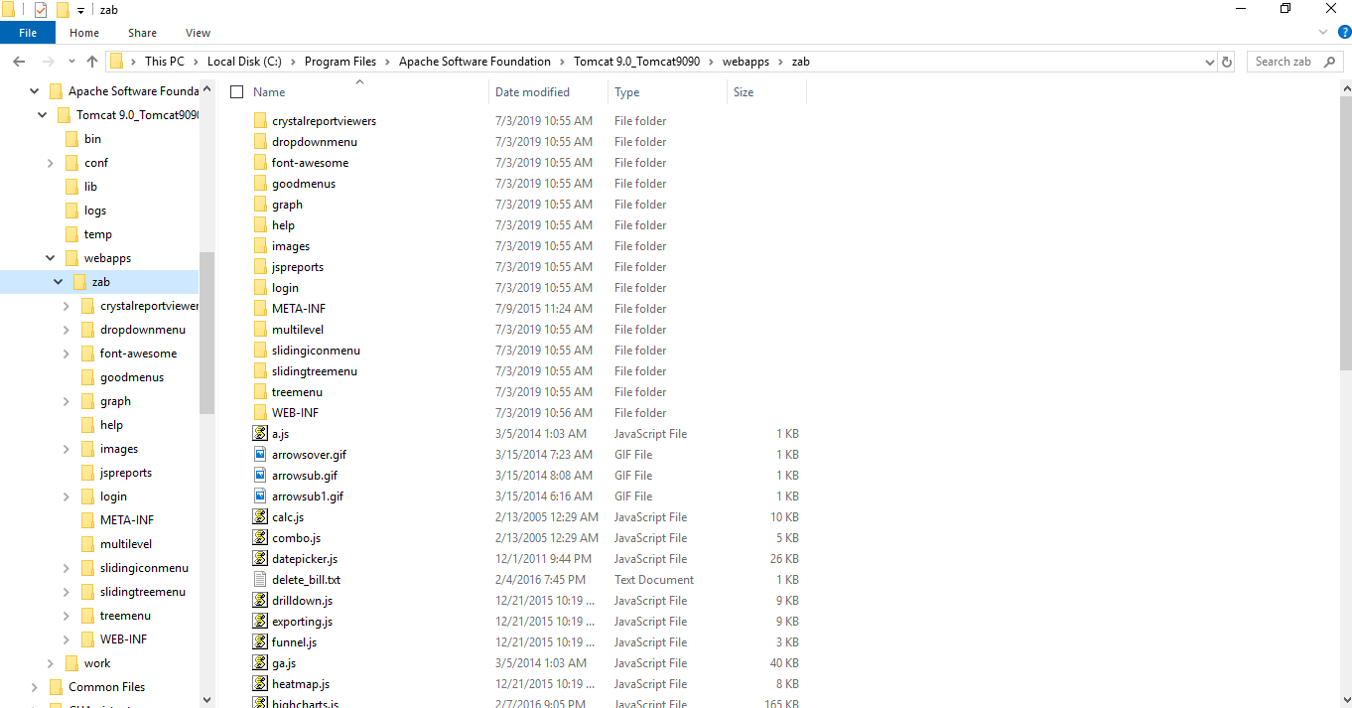

**Step 2 : Under zab > WEB-INF put or replace specific business reports folder and resource folder ( picture bellow )**

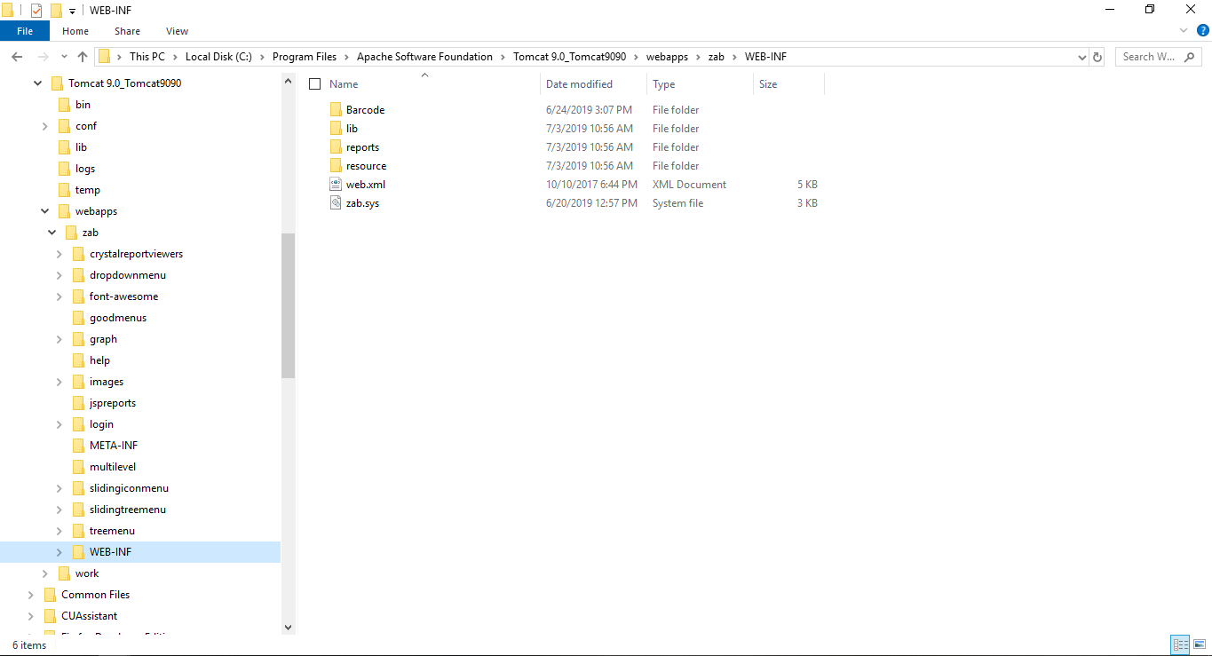

**Step 3 : On zab.sys file make sure your database connection name and database credential and other configurations are correct.**

**Step 4 : Now restart the tomcat server and type URL on web server (if tomcat connection port is 9010 ) type the following url on browser.**

**e.g: (**[localhost:9010/zab/login](http://localhost:9010/zab/login)**)**

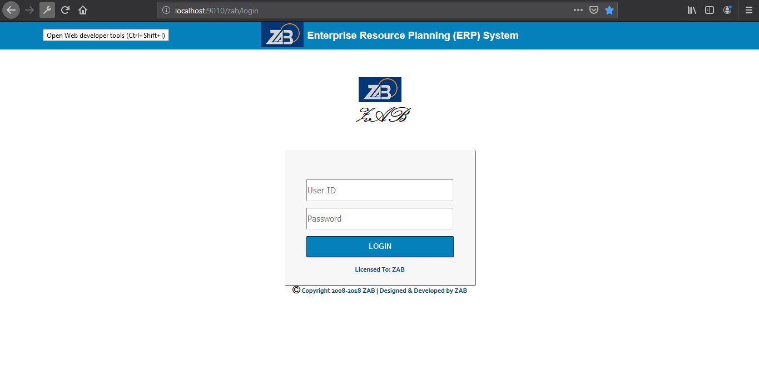

* User Account Privileges

|  |  |
| --- | --- |
| **Step 1** | Enable **Administrators Account** (default windows account-by default it is disabled) and set password ( **Computer Management > Local Users and Groups > Administrators properties > Account is disable(**Uncheck**) > apply > ok** ) |
| **Step 2** | If necessary manage others User privileges from **Local Users and Groups > User properties**. |

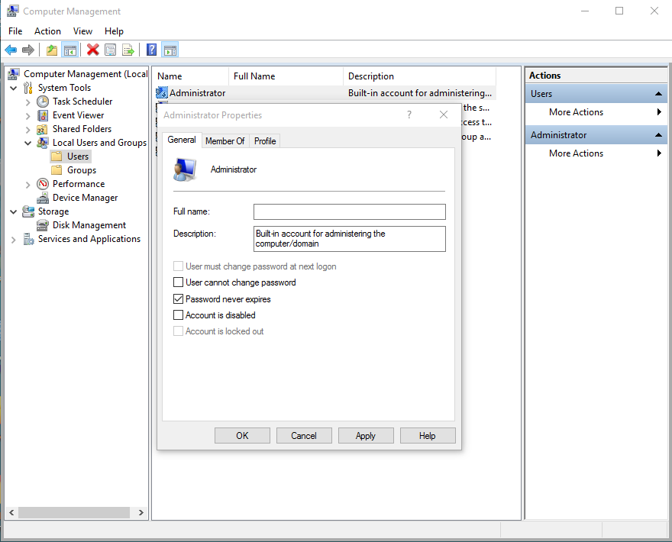

* **Software Installation with Administrator right**
* E.g. JAVA, Notepad++, Apache Tomcat, SQL server, AnyDesk.
* **Enable Remote Desktop :** From **system** properties > Remote Settings > Allow remote connection to this computer

**(Alternately you can use AnyDesk )/Optioal**

* 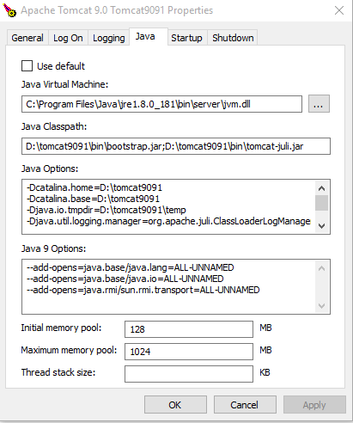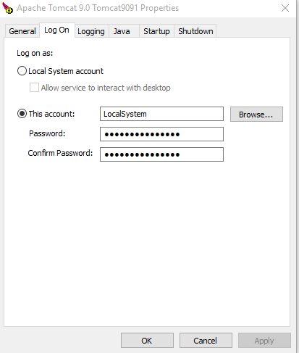**Apache Tomcat Configuration**

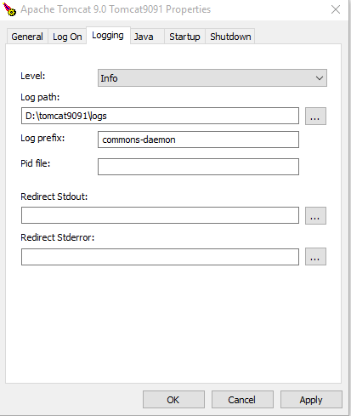

|  |  |
| --- | --- |
| Step 1 | Open tomcat Commons Daemon Service Manager(Or from Service) from bin folder(tomcat\bin) |
| Step 2 | From **General Tab** > Set Start up type Automatic or manual. |
| Step 3 | From **Log On Tab** Manage Log On User (This Account > browse and choose User Account). |
| Step 4 | From **Logging Tab** Clear **auto** from Redirect Stdout and Redirect Stderror fields keep empty for not creating log file. |
| Step 5 | From **Java Tab** increase Maximum memory pool size e.g. 1024 or optimum size. |

* **JAVA Configuration**

|  |  |
| --- | --- |
| Step 1 | Open - Configure Java |
| Step 2 | From **Java Tab** > View > Runtime Parameters > set **(-Xms1024m**) or optimum size  [in general set **¼** of computer ram size; if ram size less than 4 GB then keep it default] |

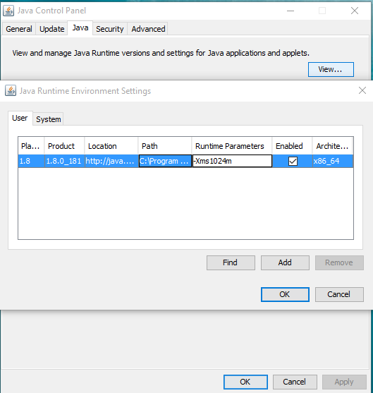

**--------** **POS Device --------**

* **Configuration of POS Device :**
* **Printer :** Set up Default Printer
* **Browser:** Set logging page as startup page/home page.
* **Device Power option :**Set Never both in **Screen Off and Sleep** from setting(Display > Power and sleep options)
* **Enable Remote Desktop :** From system properties > Remote Settings > Allow remote connection to this computer .

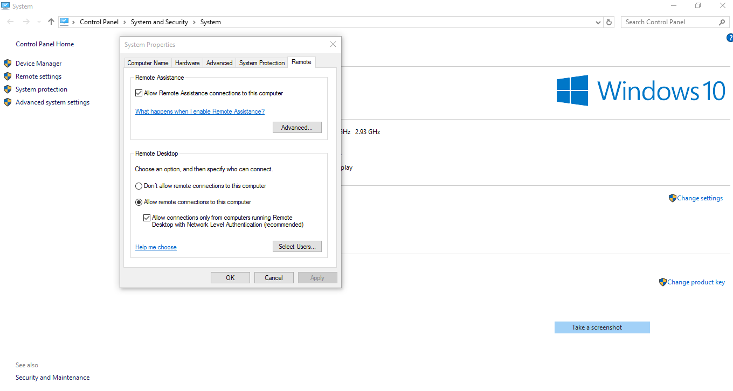

* **Configure zab.sys file( POS DEVICE)**
* **Set --product ZAB POS 🡪 “ POS “ keyword is mandatory for pos software**
* **Branch setup 🡪 Set “branch yes “ for enabling branch .**
* **POS TERMINAL NAME🡪 SET POS TERMINAL number (outlet no + terminal no)**
* **DB Name(DATABASE URL) : set database url name Database name correctly.**

**e.g. 🡪 dburl "jdbc:sqlserver://localhost;databaseName=ZABDB"**

* **Set DB User Name & Password : e.g. 🡪 dbuser "abc" dbpassword "abc"**
* **Setup simultaneous Remote login for multiple users**

1. Run -> gpedit.msc -> enter
2. Administrative Templates -> windows Component -> Remote Desktop Services -> remote desktop session host -> connections
3. Go to Restrict Remote Desktop Services users to a single Remote Desktop Services Session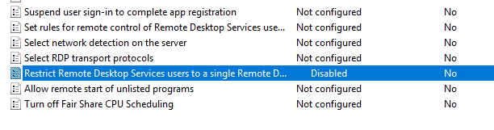
4. 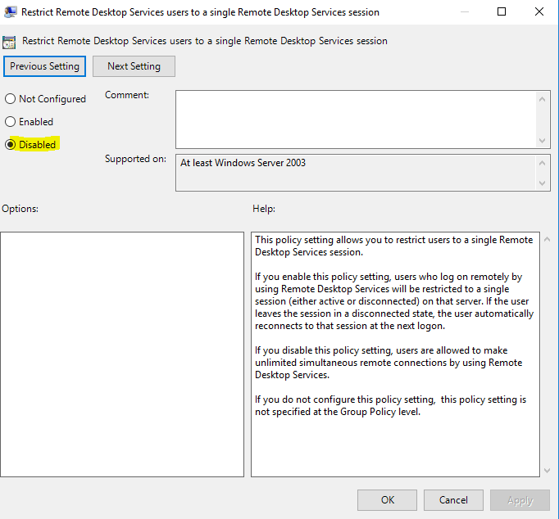Select Disabled. Click OK.
5. Go to Limit number of connections.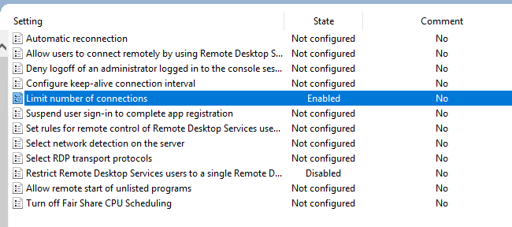
6. Select Enabled. Change ‘RD Maximum connections allowed’ to the desired connection allowed.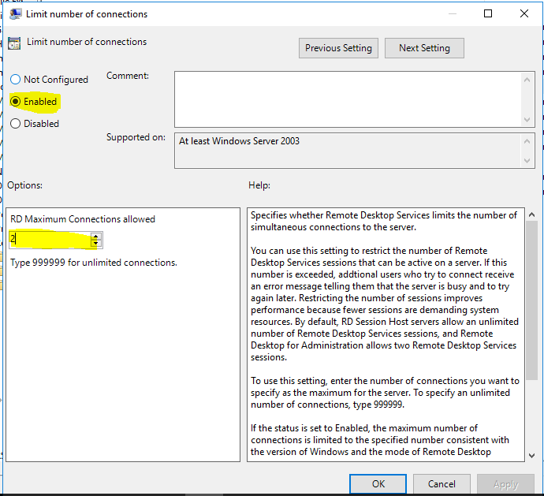

This will enable 2 simultaneous logins for Remote connection. In case Remote Desktop session host is not installed maximum connections allowed for remote login is 2.

* **SQL Server Installation Prerequisite**
* **Enable Windows Automatic Update on.**
* **Make sure device is connected to the internet.**
* **SQL Server Installation Steps**

**Step 1:** Open installation media in new window and right click on setup file to run it “**As Administrator**”.  
  
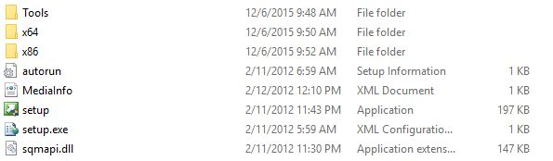

**Step 2:** **Installation Center**  
  
After running the setup file, you’ll be redirected to Installation Media Center where you find various options. As we’re working on the installation, we won’t dig other parts. Click on Installation section and you’ll find something like the following window.  
  
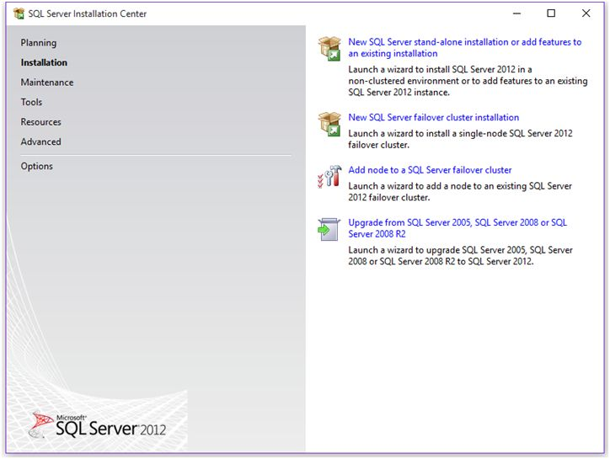  
  
From here, you can perform stand-alone installation of SQL Server or you can add any additional features to installed instances of SQL **Server.** Also if you want to upgrade you version of SQL Server, there’s an option for that as well.  
  
As we want to perform stand-alone installation, we’ll go with option 1. Click on the first link and the installation process begin.  
  
**Step 3: Setup Support Rules**  
  
Before proceeding with the installation steps, SQL Server setup runs a setup to check all the things required for installation. This check is nothing but a kind of verification to ensure you can proceed further or not.  
  
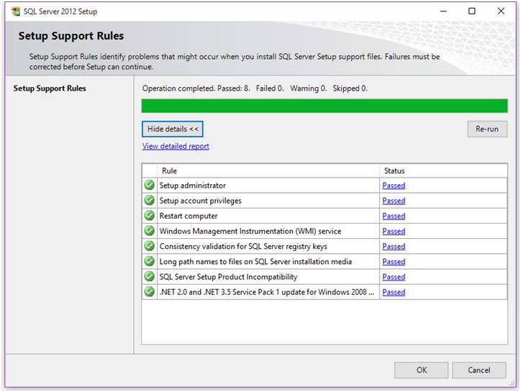  
  
If any of the check fails, you’ll get a failed notification in status column and you won’t be able to proceed further with the installation. If all requirements fulfill, you’ll get passed in Status column. Click OK.  
  
**Step 4:** **Product Key**  
  
Select edition of SQL Server you want to install on your machine with your product key and click Next.  
  
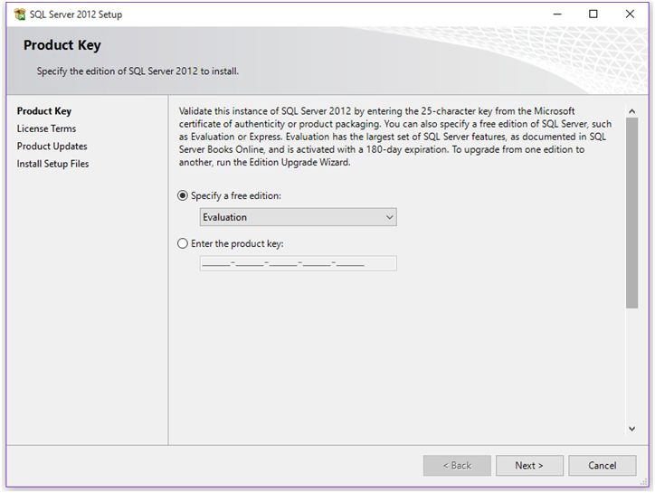  
  
**Step 5: License Term**

Accept the license by clicking on “I accept license terms.” Click Next.  
  
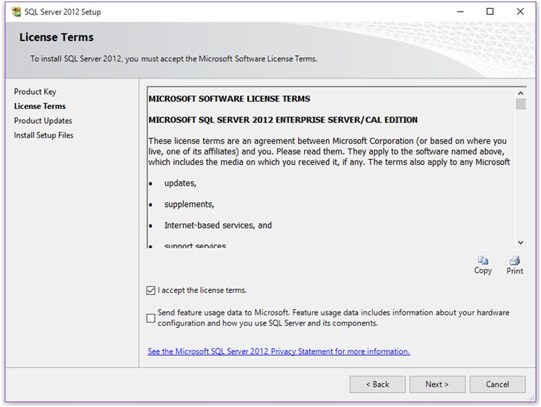  
  
**Step 6: Product Updates**  
  
Here, setup will look for latest product updates to enhance SQL Server performance as my setup found one update of 22 MB for enhancement as shown below.  
  
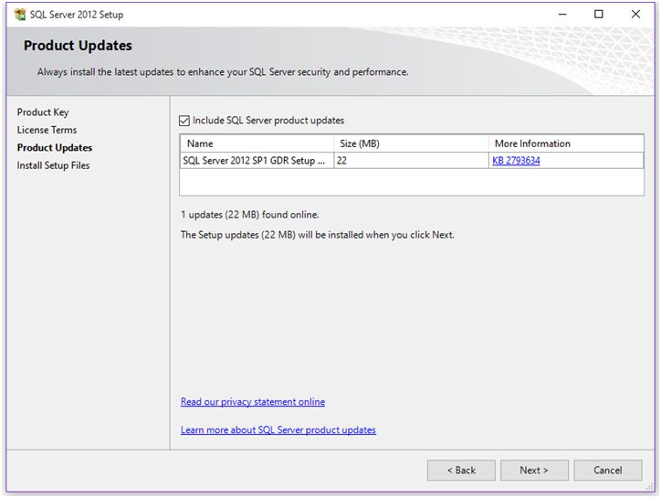  
  
**Step 7:** **Install Setup Files**  
  
At this window, you’ll get **Install** button to install the updates.  
  
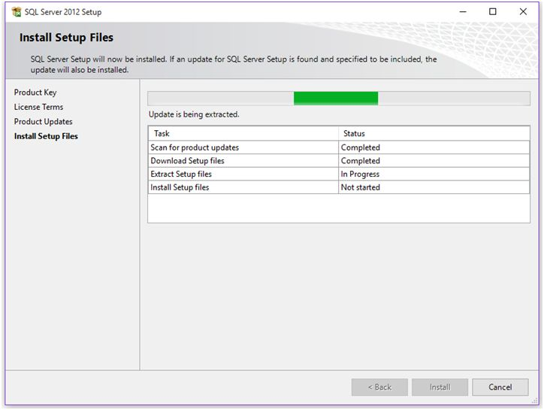  
  
**Step 8: Setup Support Rules**  
  
After successful completion of previous step, setup will again run a check to ensure everything looks good for the installation.  
  
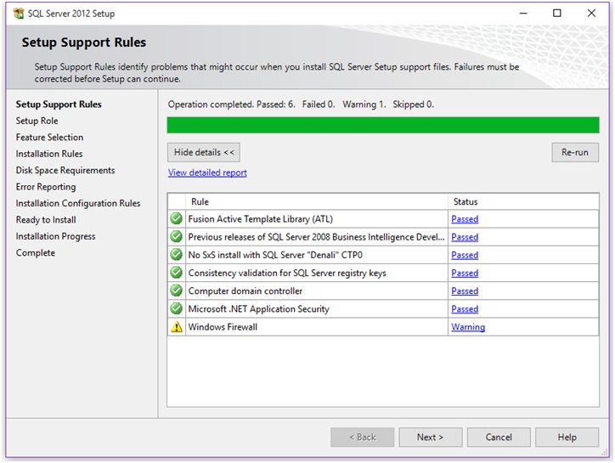  
  
**Step 9: Setup Role**  
  
At this step, you’ll find options like install SQL Server instance or install instance of Analysis Service with SharePoint integration. By default it’ll select ‘**SQL Server Feature Installation**’.  
  
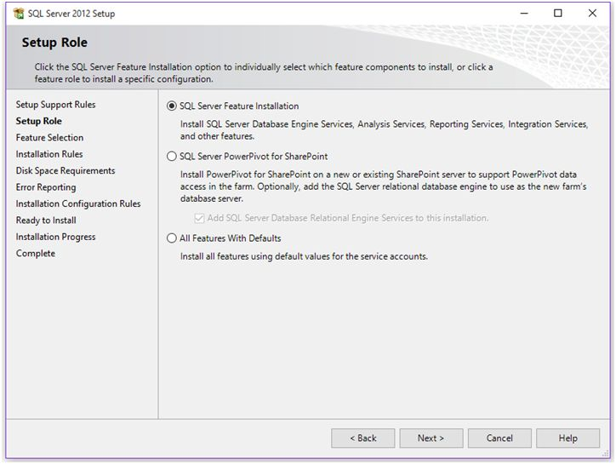  
  
If you select “**All Features with Default**”, the following things will be set by default:

* **On the Feature Selection page**, all features will be selected by default.
* **On Server Configuration page**, default accounts will be set.
* **On Database Engine Configuration page**, your current logon account will be added as a Server Administrator.

**Step 10: Components or Features to Install**  
  
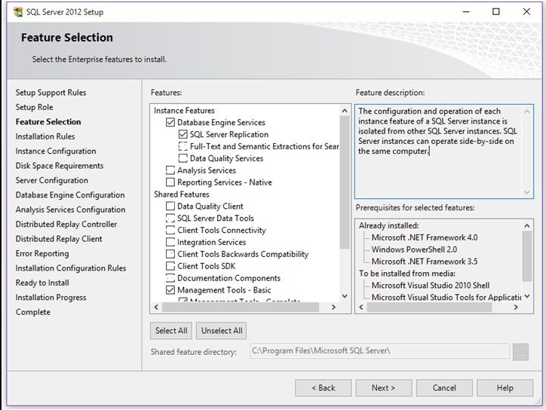  
  
Only Checked the **Database Engine Services** (Only check SQL Server Replication) **and Management Tool**

* **Database Engine Services:** Allow you to install SQL Server instance.
* **Management Tool:** Allow you to install SQL Server management configuration tool including command line and power shell tool.  
    
  **Step 11: Installation Rules**  
    
  After selecting the features to install, setup again runs a check to ensure whether your machine’s configuration is compatible or not to proceed further.  
    
  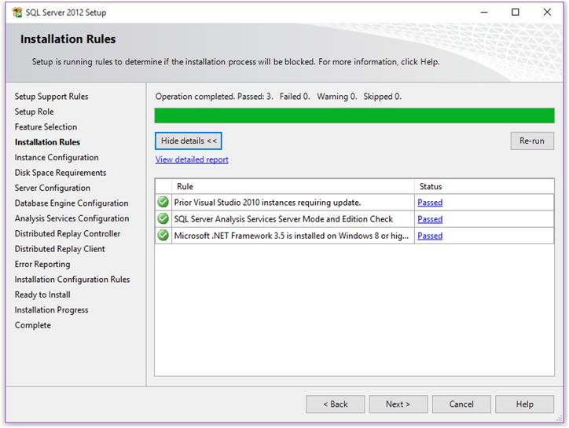  
    
  If all looks good, click **Next.**  
    
  **Step 12:** **Instance Configuration**  
    
  This step will ask, what type of instance you want to configure, as we all know, either we can **install Default** or Named instance. If default instance is already installed, you’ll have to have proceeded with named instance.
* After doing instance configuration, click **Next.**  
    
    
  **Step 13: Disk Space requirement summary**  
    
  At this step, you’ll get disk space summary which will show how much disk space your instance will take on the machine.  
    
  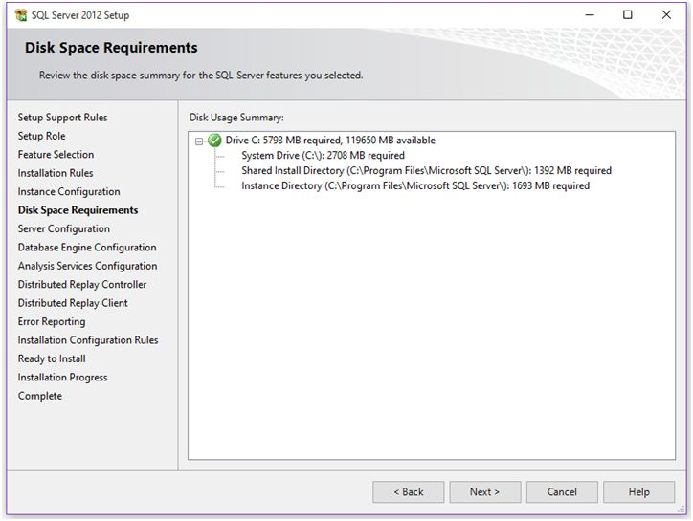  
    
  **Step 14:** **Server Configuration**  
    
  Set all services startup type Automatic. It’s recommended to set Start-up type of SQL Services to Automatic.  
  After performing above steps, click Next.  
    
  **Step 15:** **Database Engine Configuration**  
    
  This is the most important step because over here you’ll configure your servers configuration, data directories and file stream options.  
    
  At **Server Configuration** tab, you’ll find authentication mode and SQL Server System Administrator [SA] account configuration.  
    
  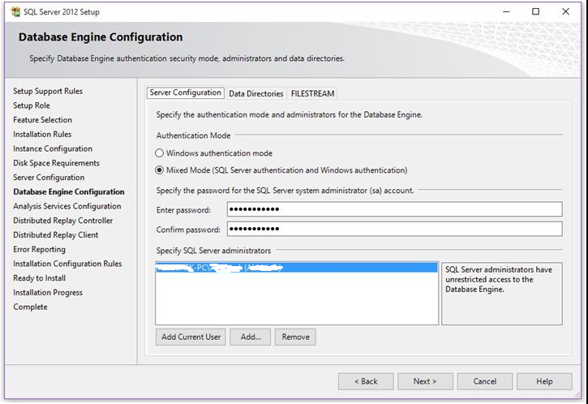
* Choose Mixed Mode and type your password
* Then Specify SQL Server administrators **Add Current User**
* After completing the steps, click Next.  
    
    
  **Step 16: Error Reporting to Microsoft.**  
    
  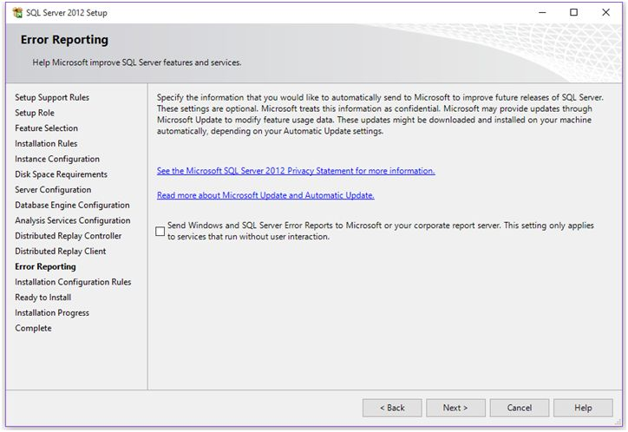  
    
  Click Next.  
    
  **Step 17: Installation Configuration Rule**  
    
  At this step, setup will perform a final check to ensure everything looks good for installation operation.  
    
  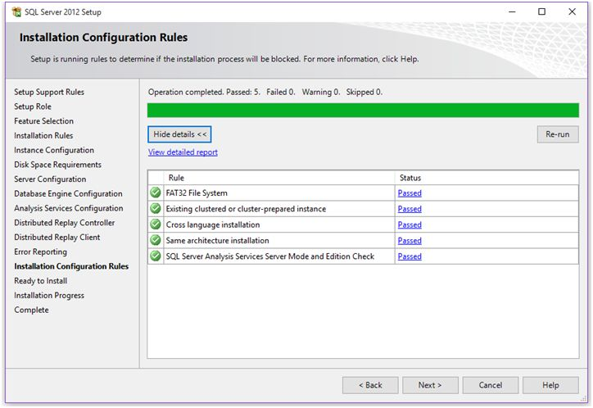  
    
  If all rule passes, click Next.  
    
  **Step 18:** **Installation Summary**  
    
  Here you’ll get summary of your installation as shown below.  
    
  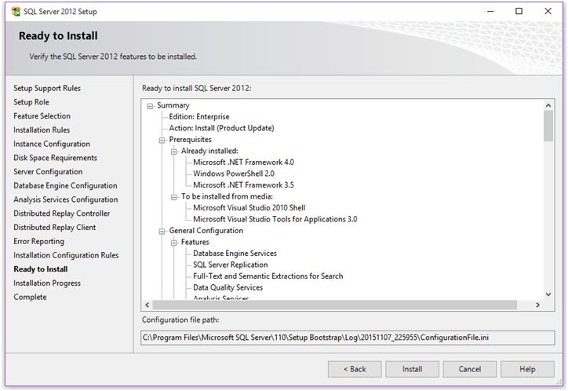  
    
  If you’re satisfied with everything, click on **Install** button and you’re set to go.   
    
  **Step 19: Installation process will start and you’ll see the progress as in the following,**  
    
  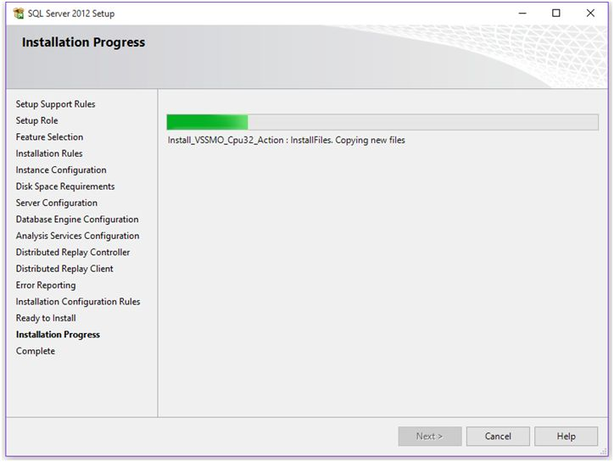  
    
  This will take some time, relax and just watch the progress.  
    
  **Step 20:** Installation completed  
    
  After successful installation you’ll get the following window. This will show you the components installed on your machine with ‘Succeeded’ message in Status column.  
    
  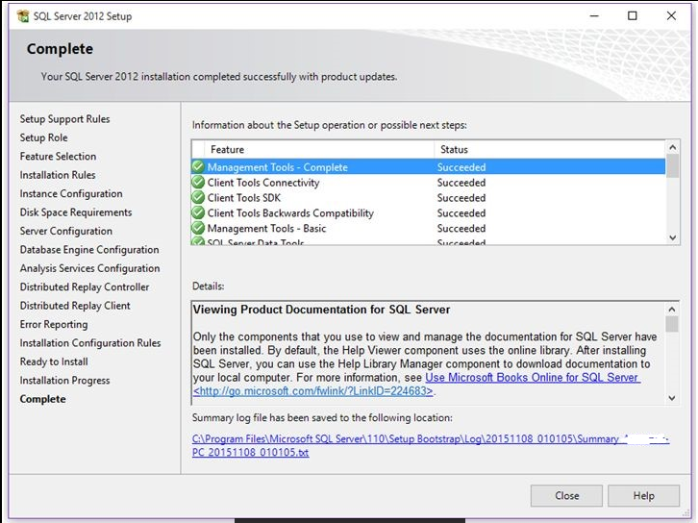

Also you’ll get location of the log file of the complete installation.

* **SQL Server Restore and Backup**

## Restore database from backup using SQL Server Management Studio

1. Connect to your SQL Server and right-click on the “Databases” directory and choose “Restore Database”

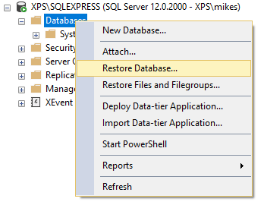  
2. Click the button beneath the “Source” section next to “Device”  
3. In the “Select backup device” press “Add”  
4. Select the backup file or files (.bak) you are going to restore, then click “OK”  
5. In the “Restore Database” window specify the database’s name you will restore and click “OK” to start[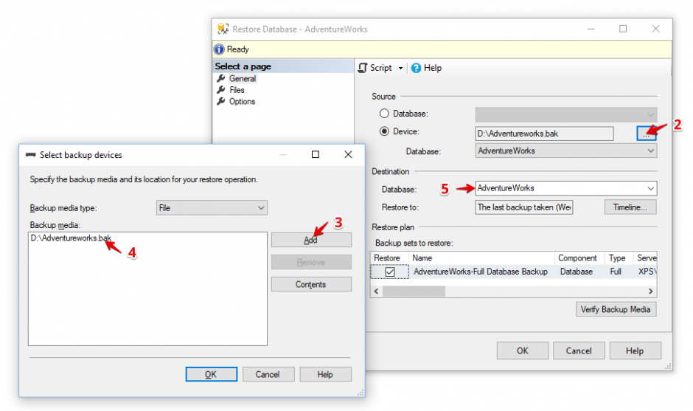](https://sqlbackupandftp.com/blog/wp-content/uploads/2016/10/ssms-restore-options.png)

Your SQL Server database is restored.

## Backup database using SQL Server Management Studio

**Step 1**: Open your Microsoft SQL Server Management Studio, whichever you prefer, standard or express edition.

**Step 2**: Using your Database Username and Password, simply login to your MS SQL server database.

**Step 3**: **Select the database >> Right-click >> Tasks >> Back Up** [as shown in the image below]:

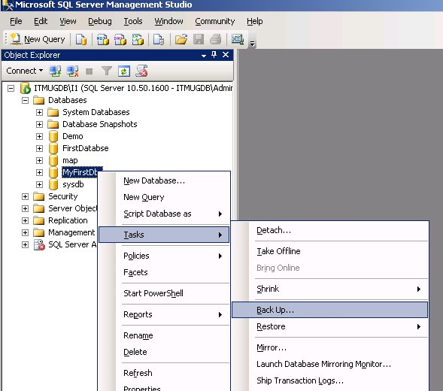

Once you click on the “**Backup**” the following Backup Database window will appear

**Step 4**: Select the following options:

1. Backup type: Full
2. Under Destination, Backup to: Disk

**Step 5**: Now, by clicking on the “**Add**” button the following window will appear to select the path and file name for the database backup file

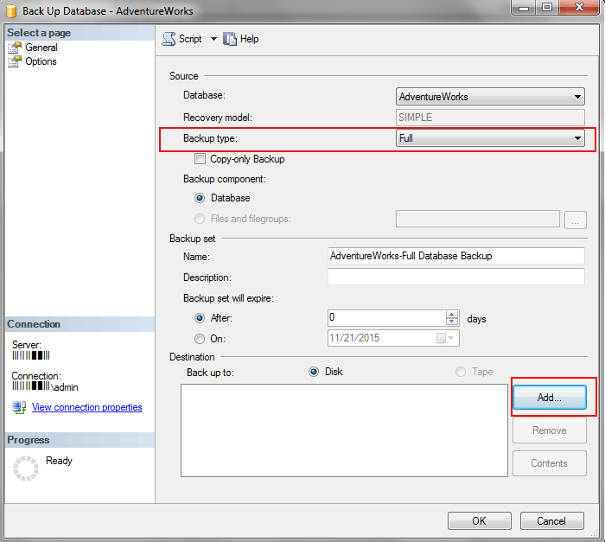

**Step 6**: Select the destination folder for the backup file and enter the “**File name**” with **.bak** extension [as shown in the image below]:

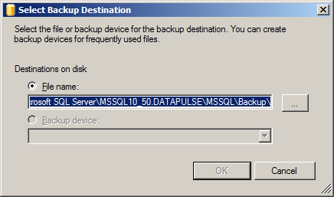

Make sure you place your MS SQL database .bak file under the MSSQL backup folder.

**Step 7**: Hit the **OK** button to finish the backup of your MS SQL Server 2008 Database. Upon the successful completion of database backup, the following confirmation window will appear with a message “The backup of database “yourdatabasename” completed successfully. [as shown in the image below]:

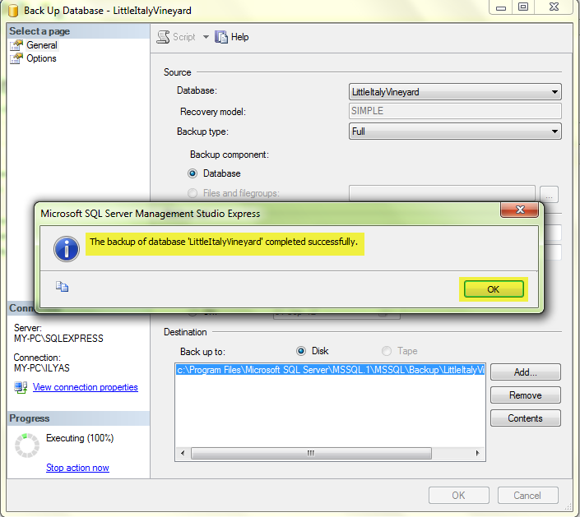

## Backup and restore using T-SQL Commands (Optional)

Of course, to keep your database safe and sound you should use backup and restore utility, it’s the easiest way to make SQL Server database backup and restore backups if the failure occurs. We have talked about how to use backup and restore utility and now we will show how to backup and restore SQL Server database using T-SQL Commands.

###### Backup and Restore Full Backup

Use the next T-SQL Command to create a full backup of your database.

BACKUP DATABASE ZABDB TO DISK = 'D:\ZABDB_full.bak'

Apply the following command to restore the full backup of your SQL Server database. This backup will overwrite your database if such is exist or create a new SQL Server database.

RESTORE DATABASE ZABDB FROM DISK = 'D:\ZABDB_full.bak'

Once you have restored your full database backup you can easily restore a differential or transaction log backups. If you want to do it, restore your full backup using NORECOVERY option. This option leaves a backup on restoring state and lets you restore extra differential or transaction log backups.

RESTORE DATABASE ZABDB FROM DISK = 'D:\ZABDB_full.bak'

###### Backup and Restore Differential Backup

The T-SQL Command to create a differential backup almost the same as to create a full backup, all you need is to add ‘WITH DIFFERENTIAL’

BACKUP DATABASE ZABDB TO DISK = 'D:\ZABDB_diff.dif' WITH DIFFERENTIAL

The T-SQL Command to restore the differential backup is the same as the Command to restore a full backup. All you need to do is don’t skip to add NORECOVERY command.

RESTORE DATABASE ZABDB FROM DISK = 'D:\ZABDB_full.bak' WITH NORECOVERY

GO

RESTORE DATABASE ZABDB FROM DISK = 'D:\ZABDB_diff.dif'

GO

###### Backup and Restore Transaction Log Backup

BACKUP LOG ZABDB TO DISK = 'D:\ZABDB_log1.trn'

If you are going to restore a transaction log backup, keep in mind, that your SQL Server database must certainly be in the restoring state. Here is the simple T-SQL Command to restore SQL Server transaction log backup.

RESTORE LOG ZABDB FROM DISK = 'D:\ZABDB_log.trn'

###### Restore multiple transaction log files using NORECOVERY option

Since we covered before you need to add NORECOVERY option to set the database in a restoring state. Below, you can discover the sample how to restore your SQL Server database using the following restore scenarios:

* Full backup
* Differential backup
* Transaction log backup 1
* Transaction Log backup 2

RESTORE DATABASE ZABDB FROM DISK = 'D:\ZABDB_full.bak' WITH NORECOVERY

GO

RESTORE DATABASE ZABDB FROM DISK = 'D:\ZABDB_diff.dif' WITH NORECOVERY

GO

RESTORE LOG ZABDB FROM DISK = 'D:\ZABDB_log1.trn' WITH NORECOVERY

GO

RESTORE LOG ZABDB FROM DISK = 'D:\ZABDB_log2.trn' WITH RECOVERY

GO

**(NOTE)**

POS SCREEN (SIGN IN & Sign OFF PRINT)

class directreports(**directOtherPrint**{opsignoonslip;5;in,st,dt,st,st;zid,div,date,user,terminal;#id,#div,#date,#user,xterminal;Print Sign On;**DP1**})

class directreports(**directPrint**{opsignoonslip;5;in,st,dt,st,st;zid,div,date,user,terminal;#id,#div,#date,#user,xterminal;Print Sign On;**DP**})